WEEK 4 - ASP.NET Core 8.0 Web API

TASK 1 :-

FruitsController1.cs

using Microsoft.AspNetCore.Mvc;

namespace WebApi_Handson1.Controllers
{
[ApiController]
[Route("api/[controller]")]
public class FruitsController2 : ControllerBase
{
private static readonly List<string> fruits = new List<string>
{
"Apple", "Banana", "Cherry", "Date", "Elderberry"
};

// GET: api/FruitsController2
[HttpGet]
public IActionResult GetAllFruits()
{
return Ok(fruits);
}

// GET: api/FruitsController2/2
[HttpGet("{index}")]
public IActionResult GetFruitByIndex(int index)
{
if (index < 0 || index >= fruits.Count)
return NotFound("Fruit not found");

return Ok(fruits[index]);
}
}
}

SCREENSHOTS(task 1):
-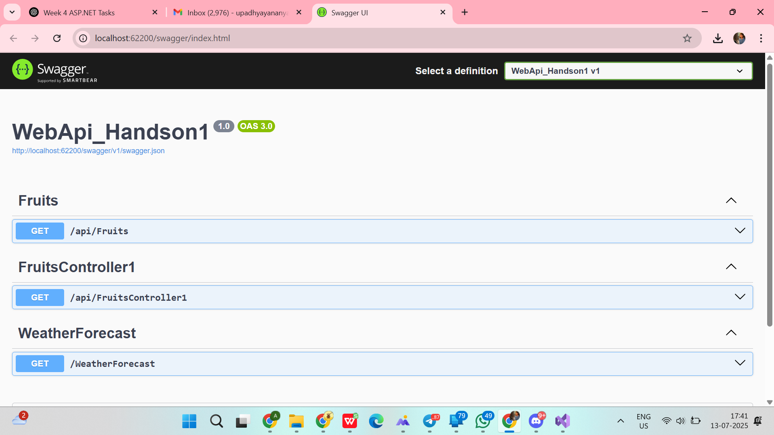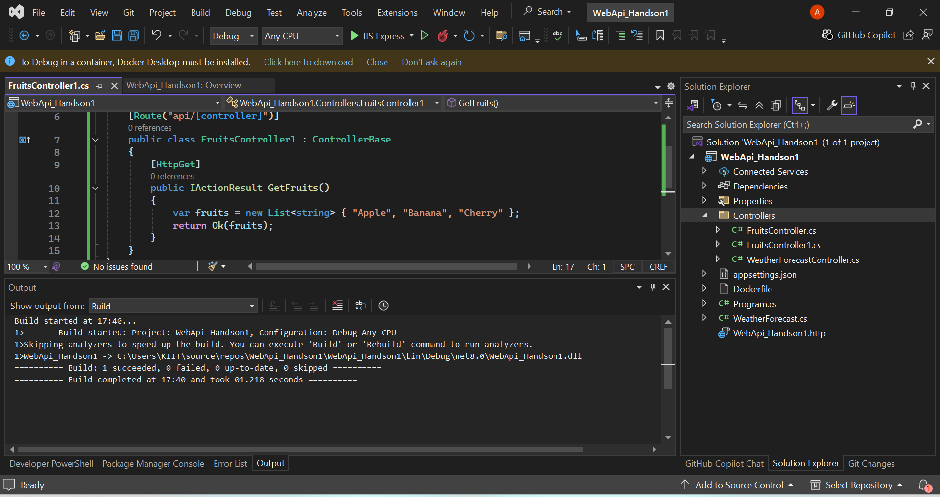
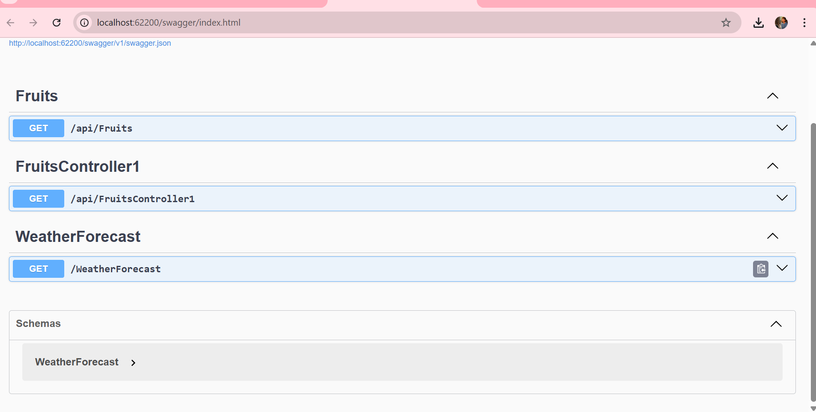

TASK 2 :-

FruitsController2.cs
using Microsoft.AspNetCore.Mvc;

namespace WebApi_Handson1.Controllers
{
[ApiController]
[Route("api/[controller]")]
public class FruitsController2 : ControllerBase
{
private static readonly List<string> fruits = new List<string>
{
"Apple", "Banana", "Cherry", "Date", "Elderberry"
};

// GET: api/FruitsController2
[HttpGet]
public IActionResult GetAllFruits()
{
return Ok(fruits);
}

// GET: api/FruitsController2/2
[HttpGet("{index}")]
public IActionResult GetFruitByIndex(int index)
{
if (index < 0 || index >= fruits.Count)
return NotFound("Fruit not found");

return Ok(fruits[index]);
}
}
}

SCREENSHOTS(task 2):-

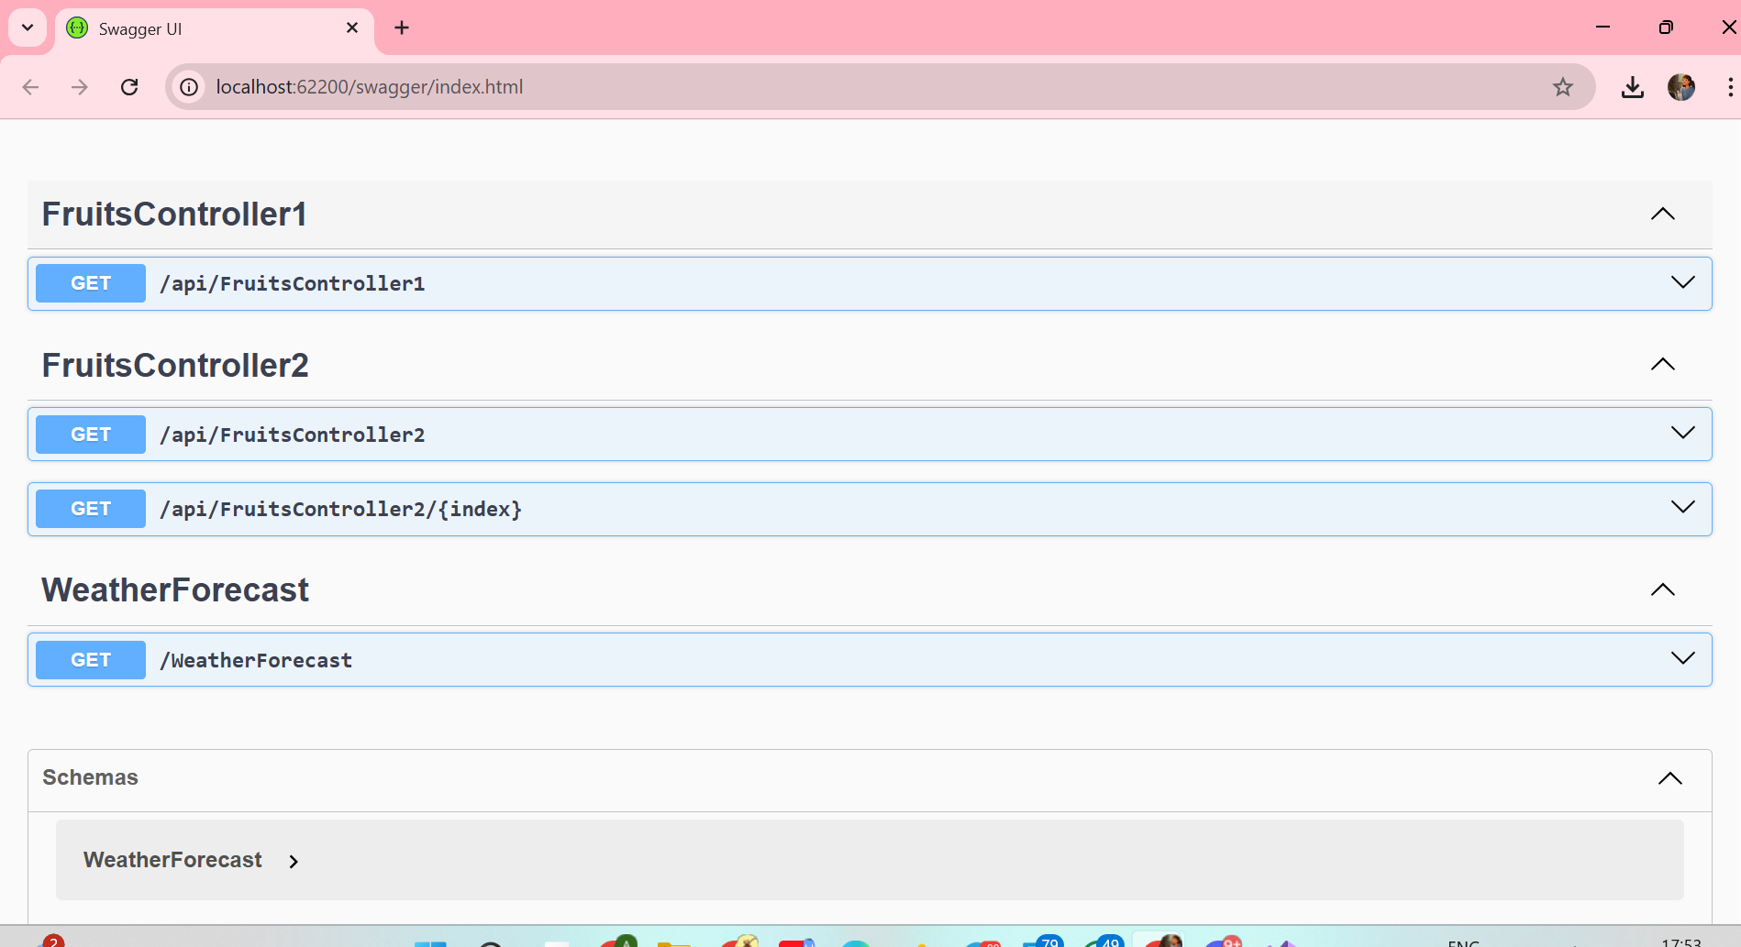
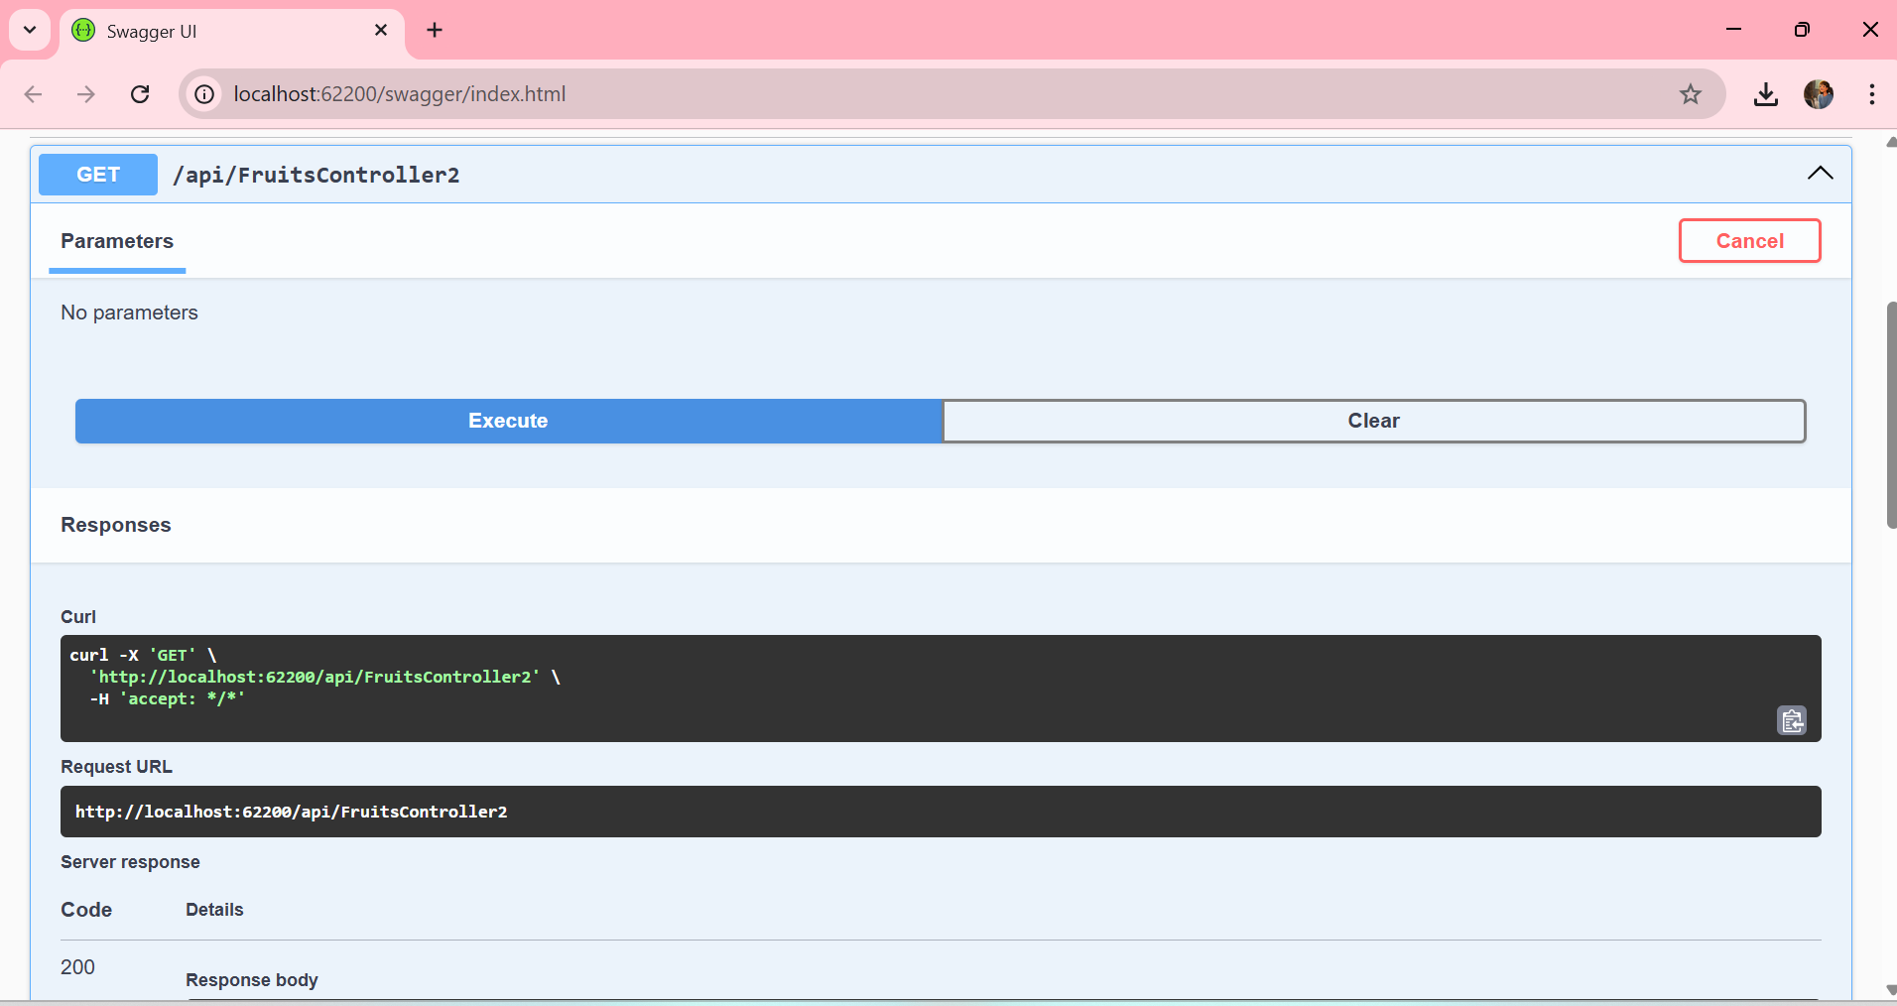
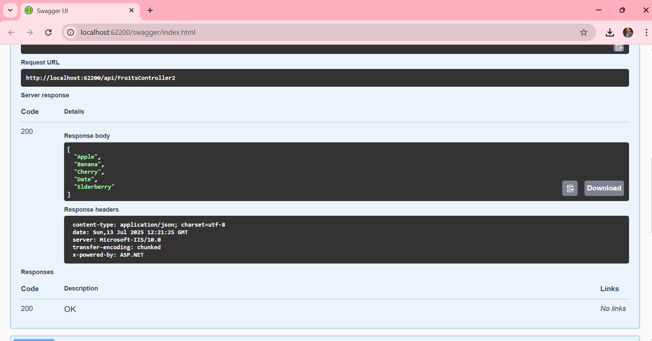
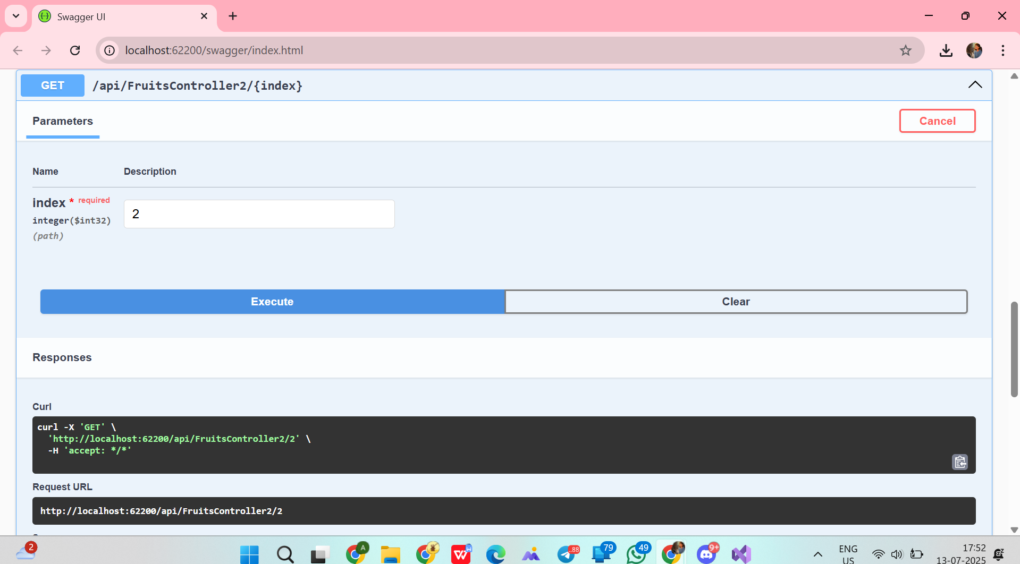
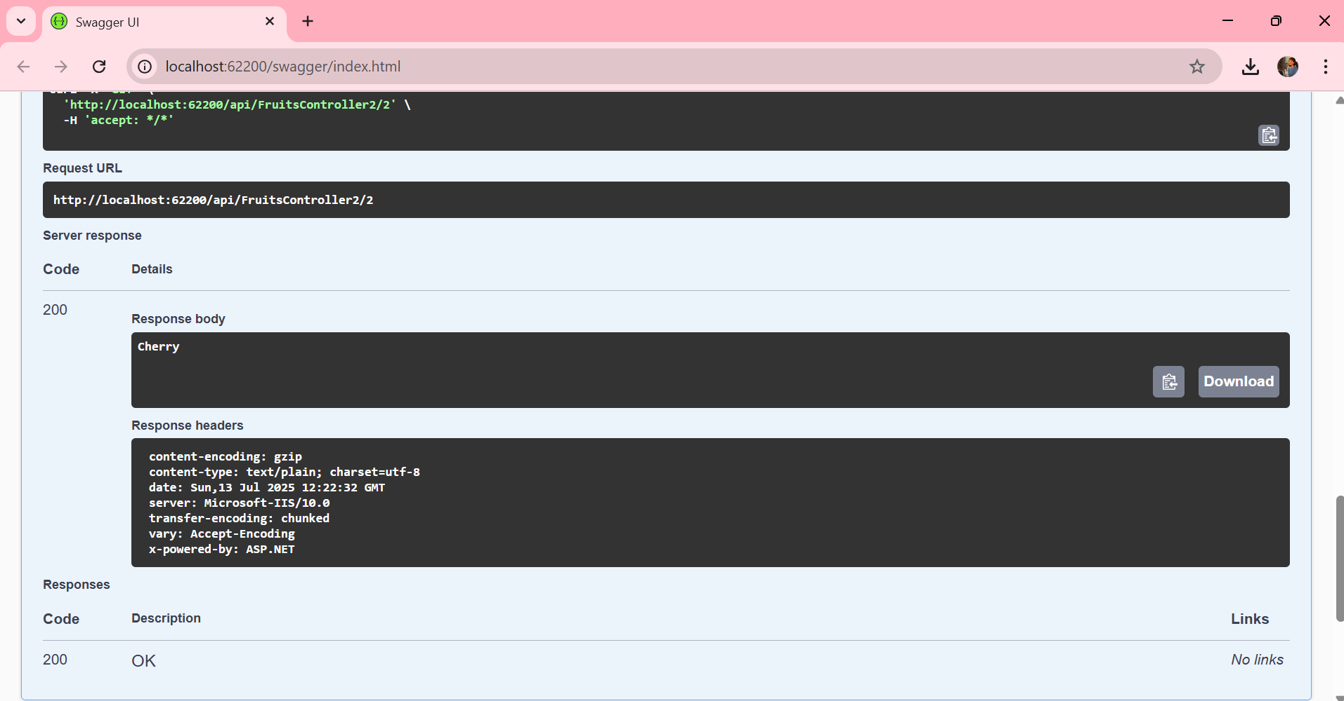

TASK 3 :-

FruitsController2.cs
using Microsoft.AspNetCore.Mvc;

namespace WebApi_Handson1.Controllers
{
[ApiController]
[Route("api/[controller]")]
public class FruitsController2 : ControllerBase
{
// Static list simulating in-memory data
private static List<string> fruits = new List<string>
{
"Apple", "Banana", "Cherry"
};

// GET: api/FruitsController2
[HttpGet]
public IActionResult GetAllFruits()
{
return Ok(fruits);
}

// GET: api/FruitsController2/2
[HttpGet("{index}")]
public IActionResult GetFruitByIndex(int index)
{
if (index < 0 || index >= fruits.Count)
return NotFound("Fruit not found.");

return Ok(fruits[index]);
}

// POST: api/FruitsController2
[HttpPost]
public IActionResult AddFruit([FromBody] string newFruit)
{
if (string.IsNullOrWhiteSpace(newFruit))
return BadRequest("Fruit name is required.");

fruits.Add(newFruit);
return Ok(new { message = "Fruit added", updatedList = fruits });
}
}
}

SCREENSHOTS(task 3):-

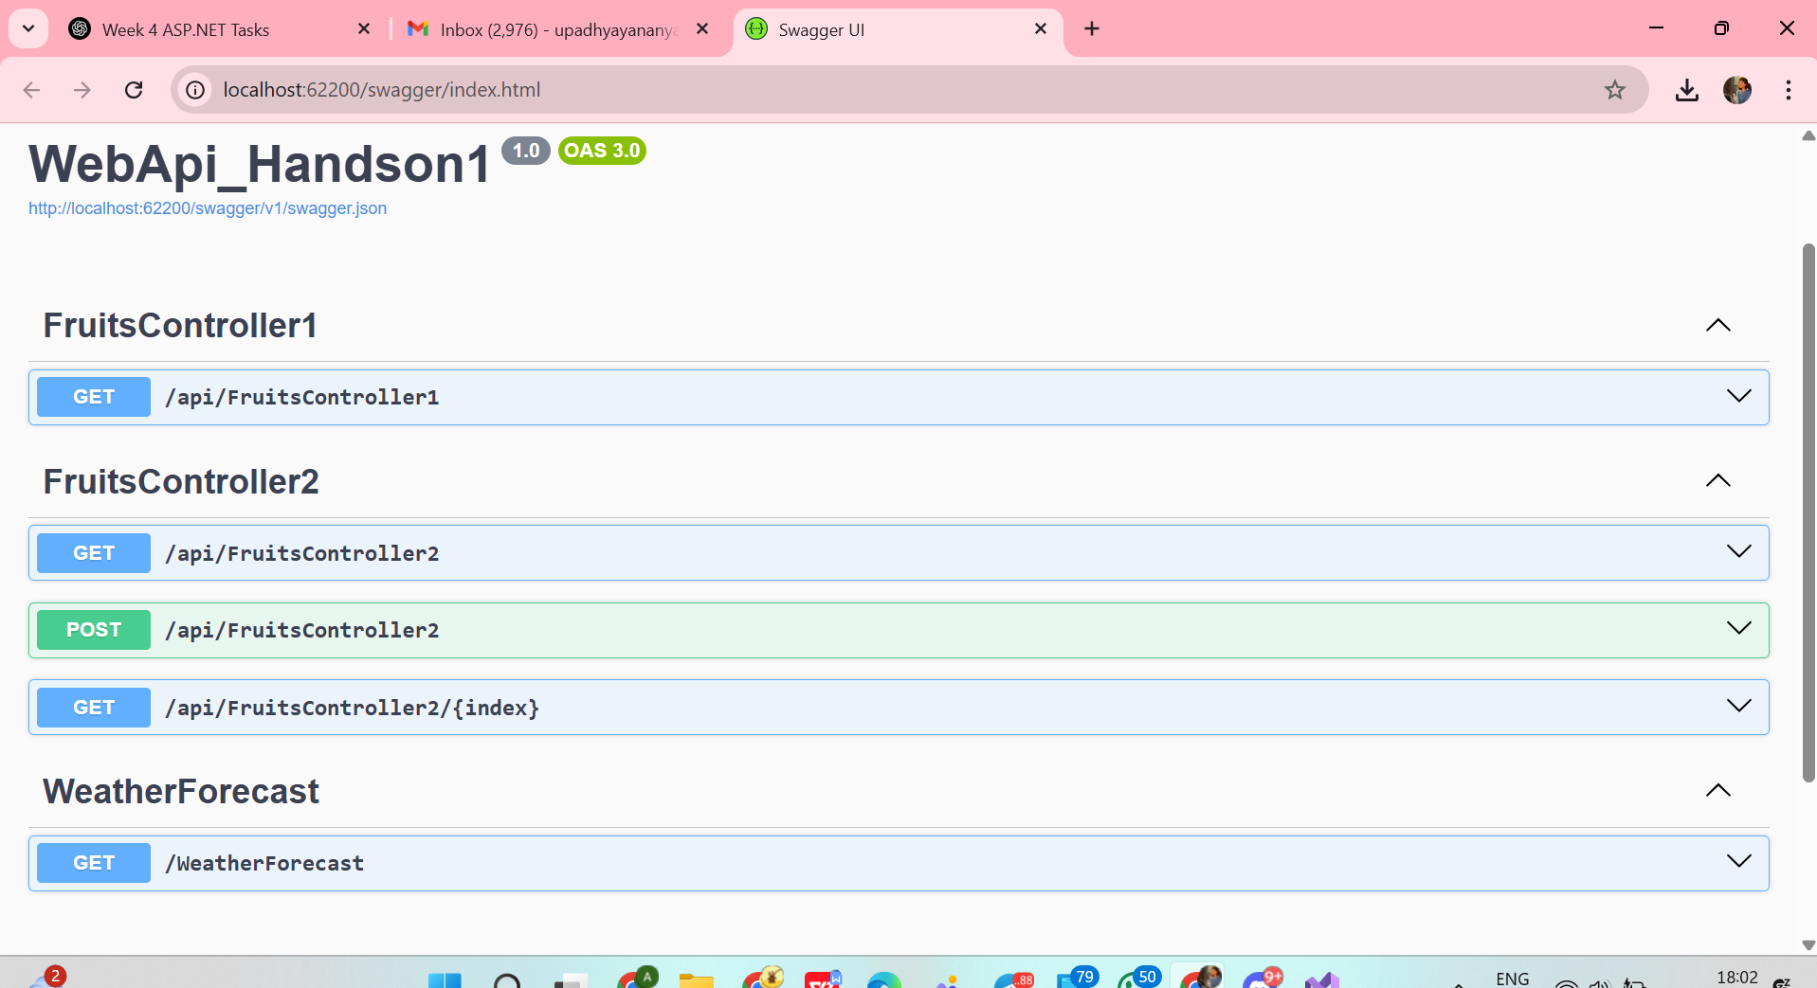
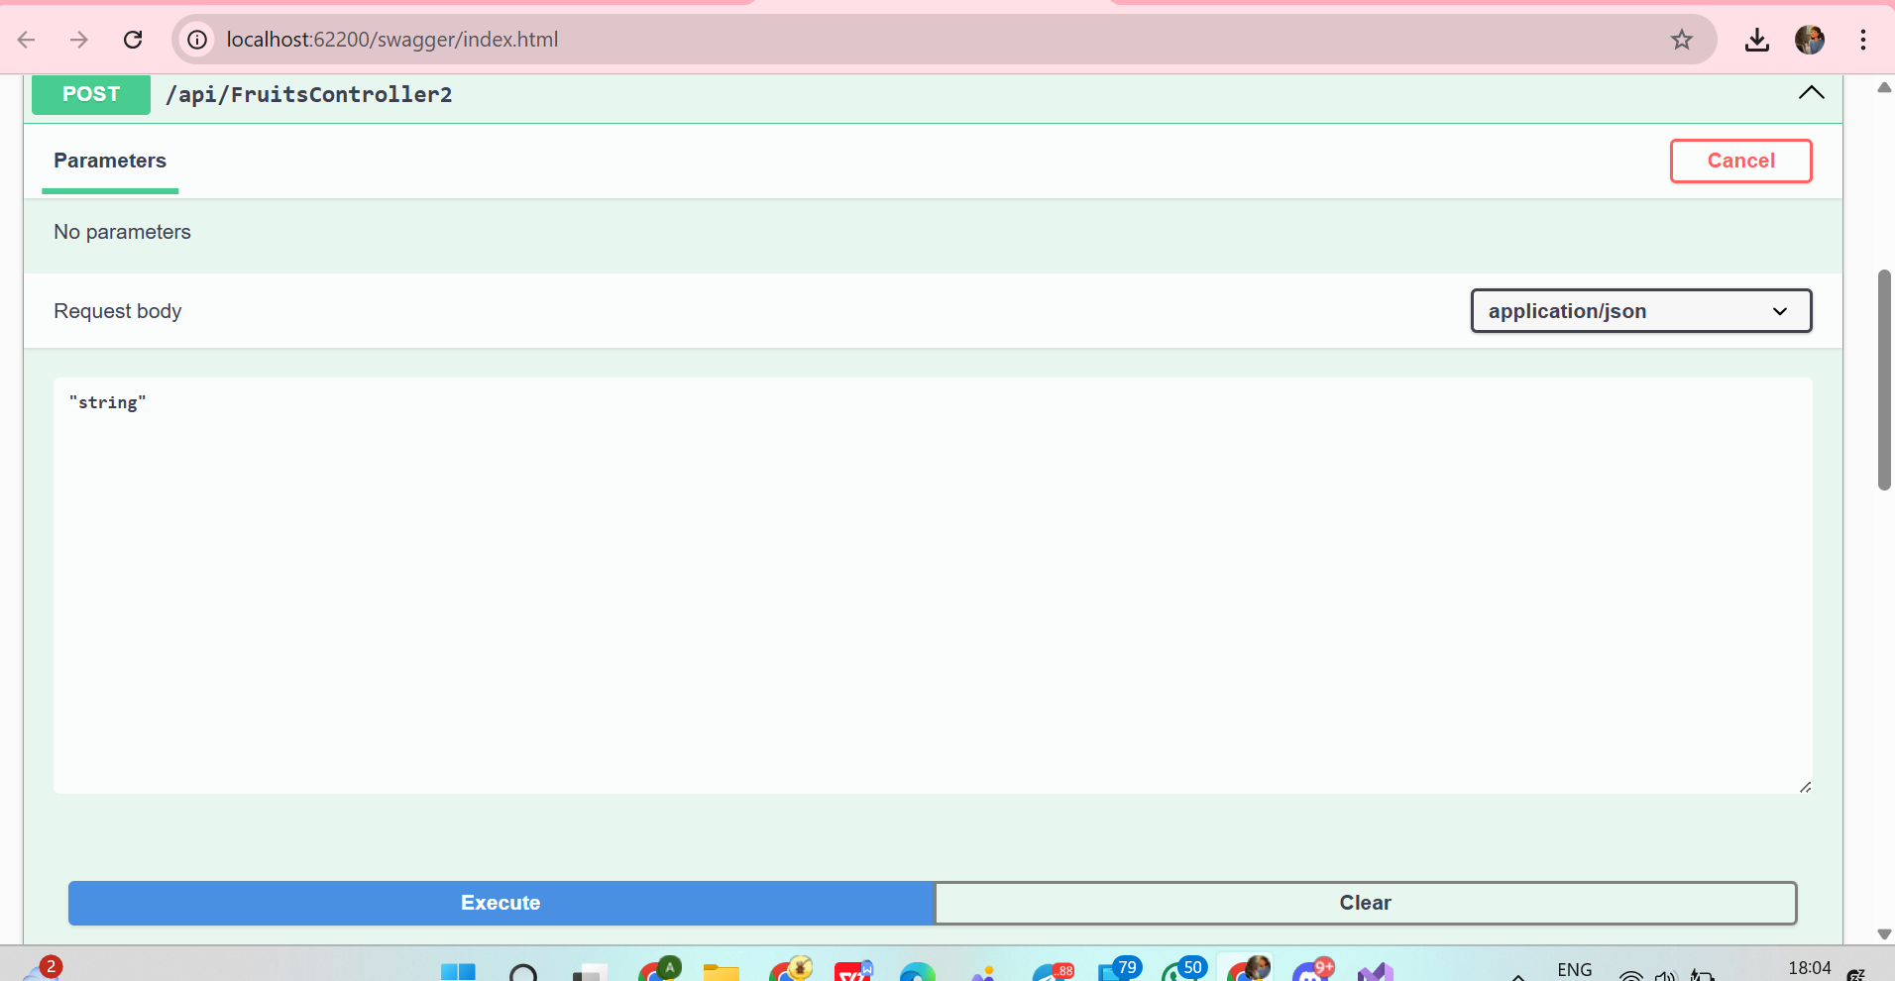
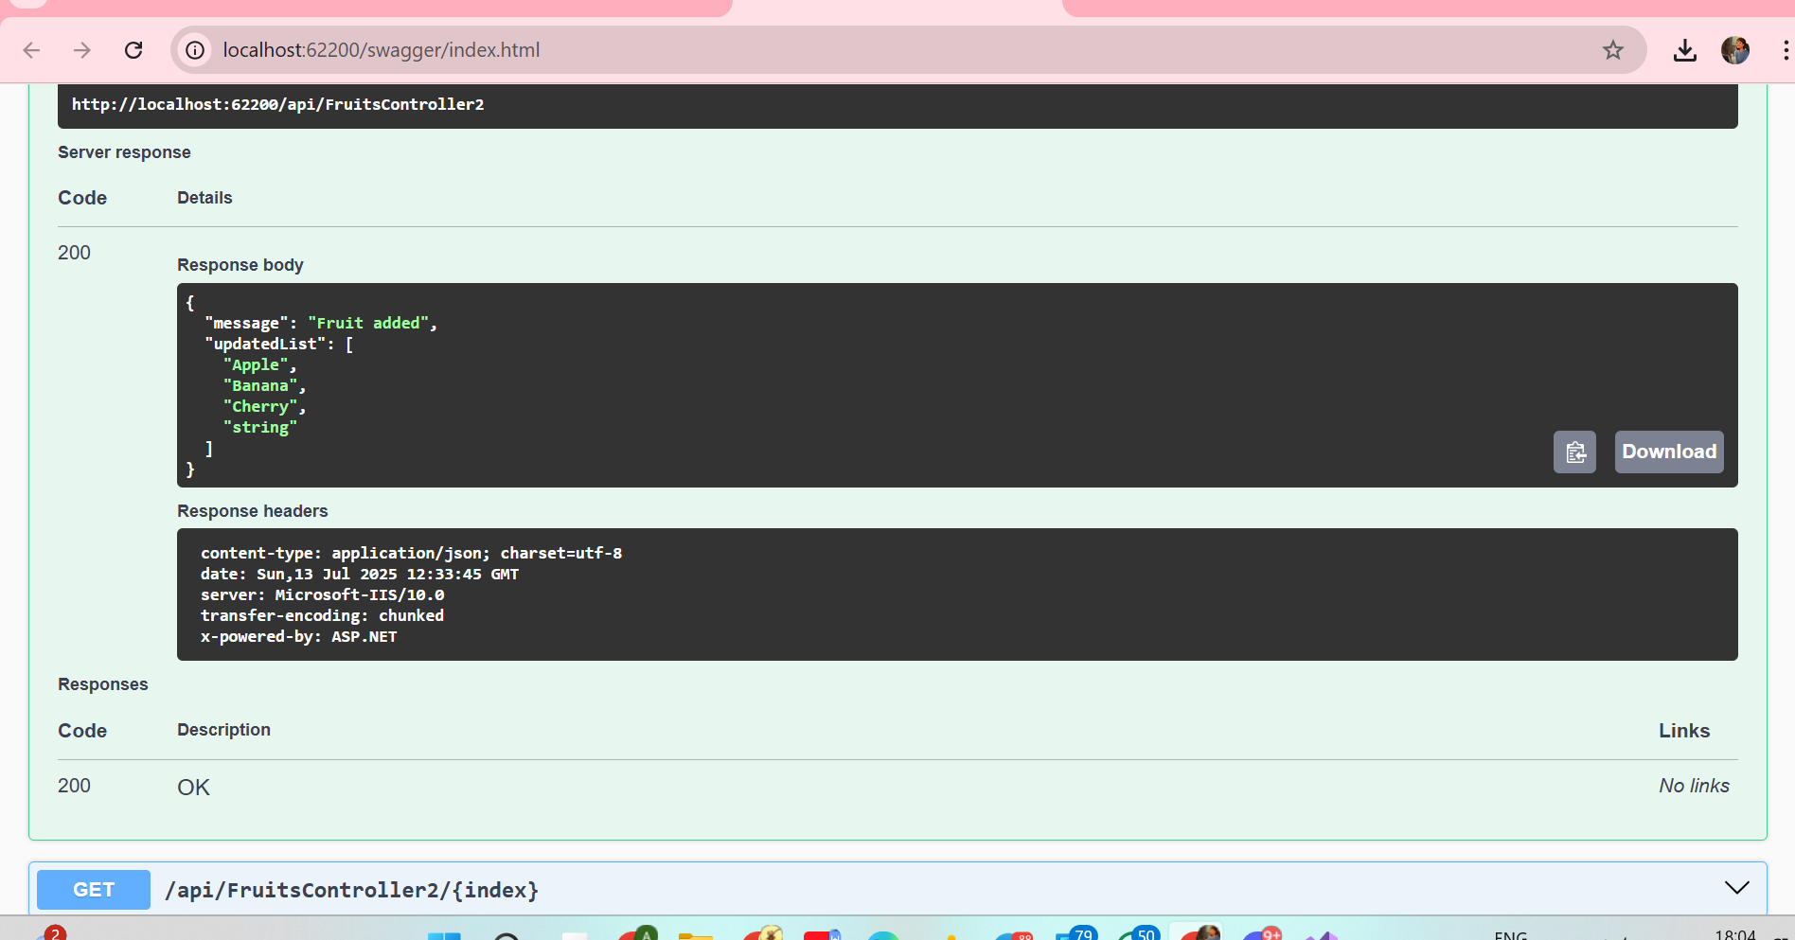

TASK 4 :-
FruitsController4.cs
using Microsoft.AspNetCore.Mvc;

namespace WebApi_Handson1.Controllers
{
[ApiController]
[Route("api/[controller]")]
public class FruitsController4 : ControllerBase
{
// Simulating in-memory data
private static List<string> fruits = new List<string>
{
"Apple", "Banana", "Cherry", "Mango"
};

// GET: api/FruitsController4
[HttpGet]
public IActionResult GetAllFruits()
{
return Ok(fruits);
}

// PUT: api/FruitsController4/1
[HttpPut("{index}")]
public IActionResult UpdateFruit(int index, [FromBody] string updatedFruit)
{
if (index < 0 || index >= fruits.Count)
return NotFound("Fruit not found.");

if (string.IsNullOrWhiteSpace(updatedFruit))
return BadRequest("Updated fruit name is required.");

string oldFruit = fruits[index];
fruits[index] = updatedFruit;

return Ok(new
{
message = $"Fruit at index {index} updated from '{oldFruit}' to '{updatedFruit}'",
updatedList = fruits
});
}
}
}

SCREENSHOTS(task 4):-

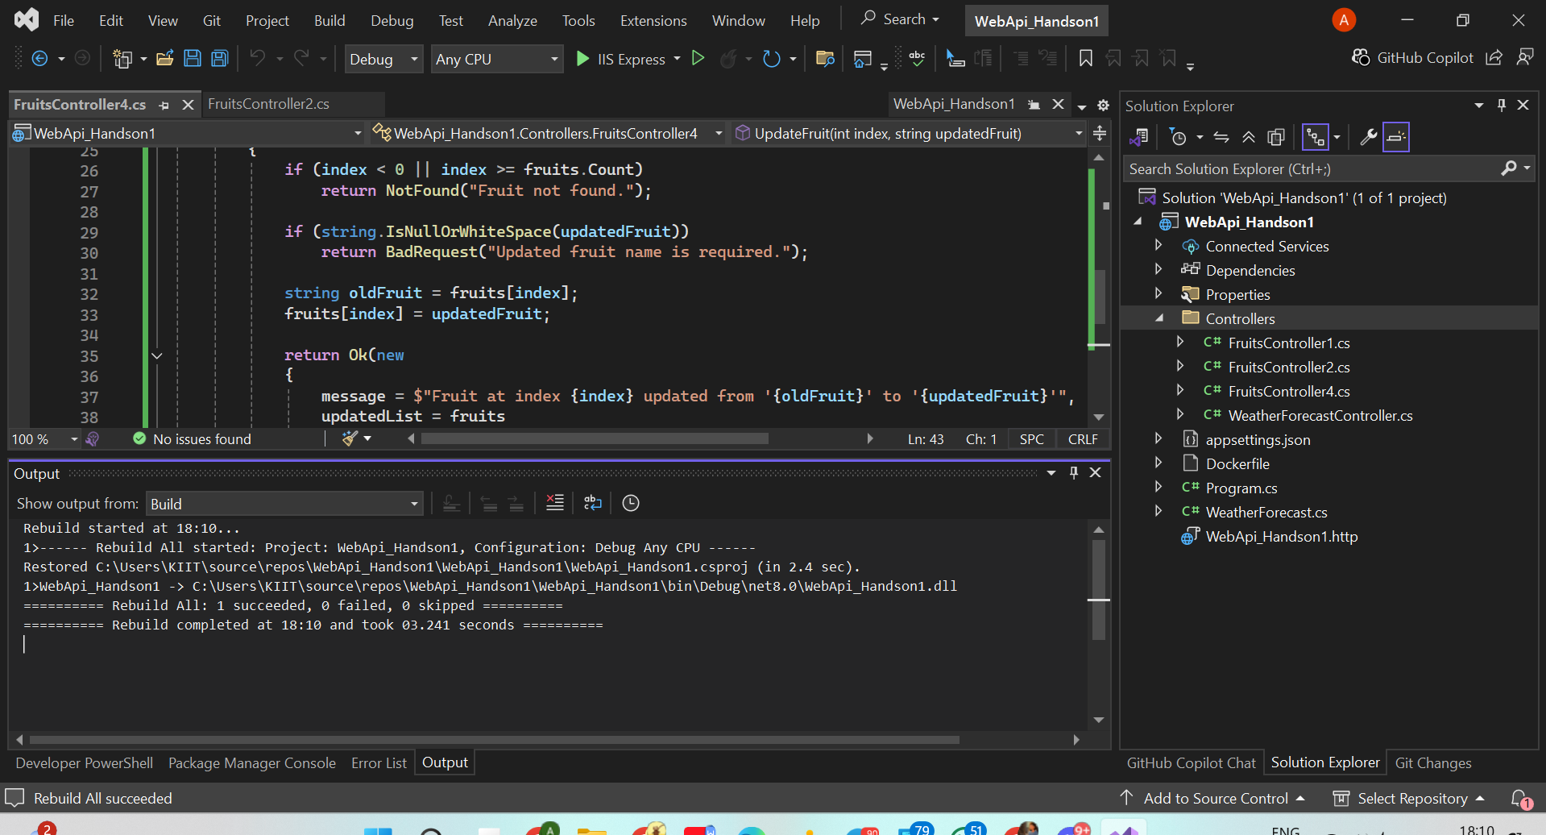

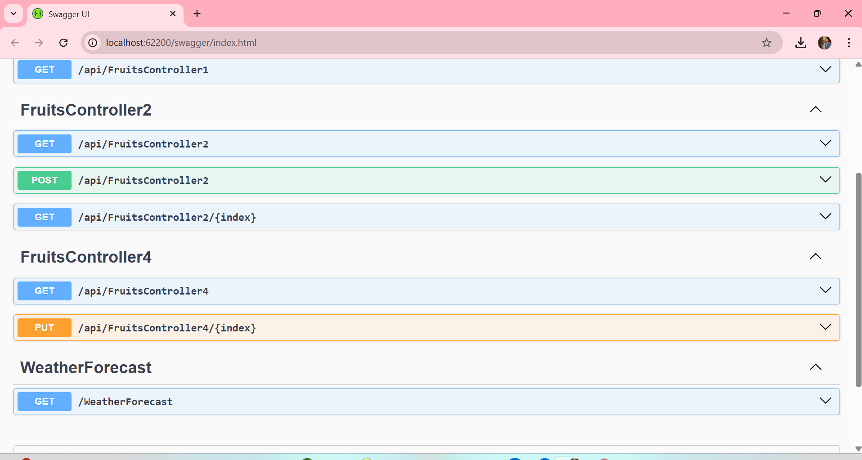
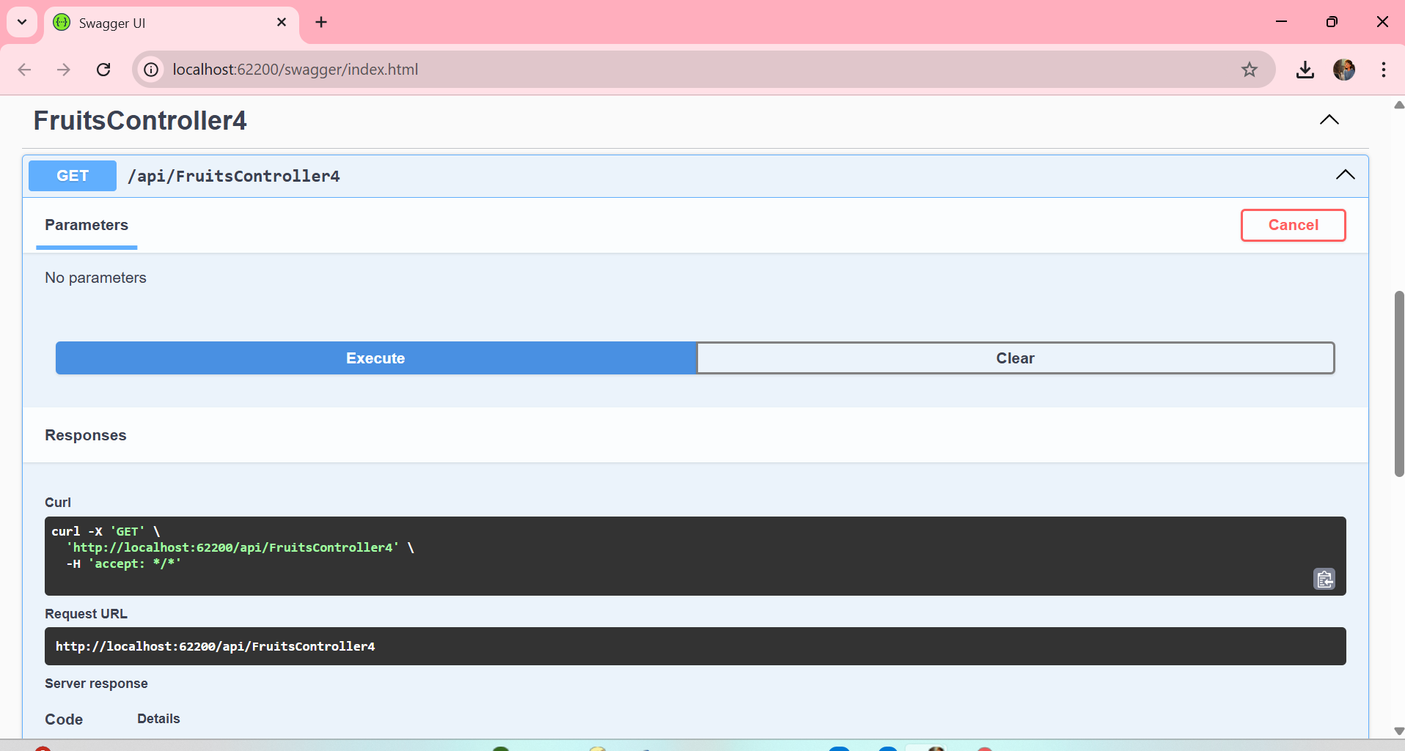
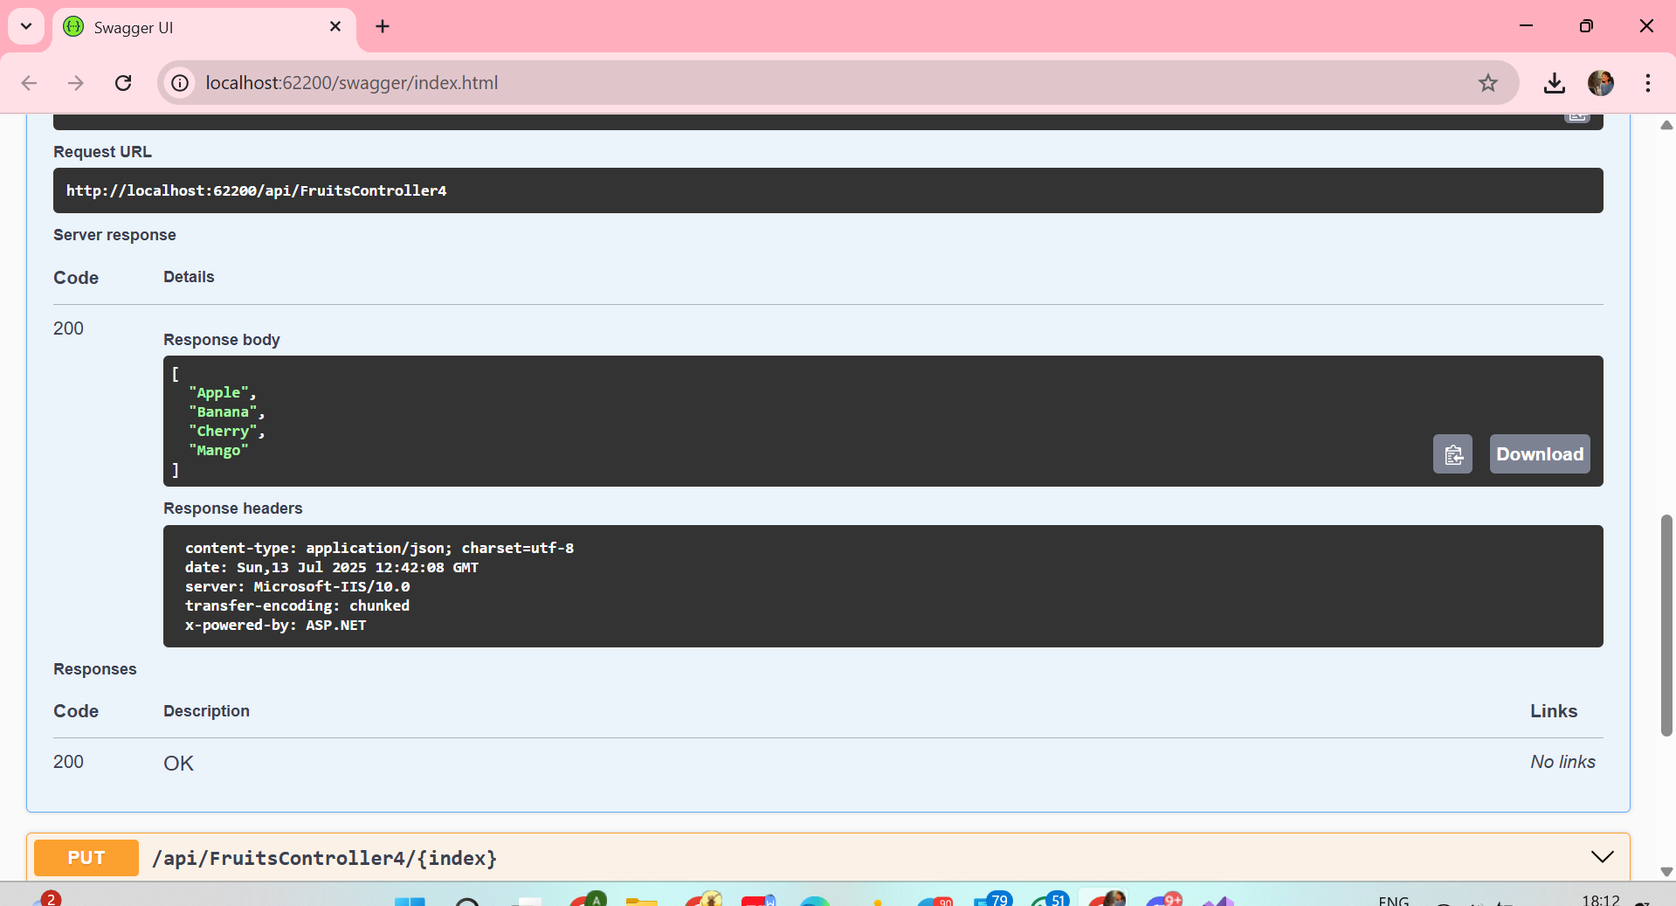
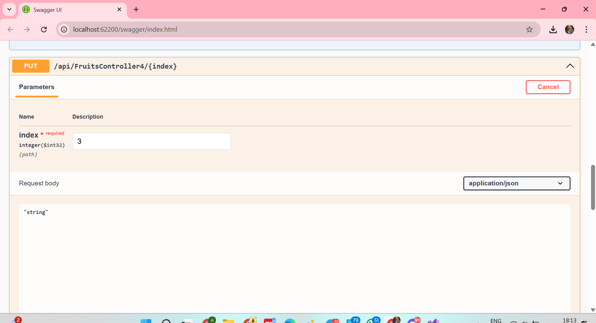
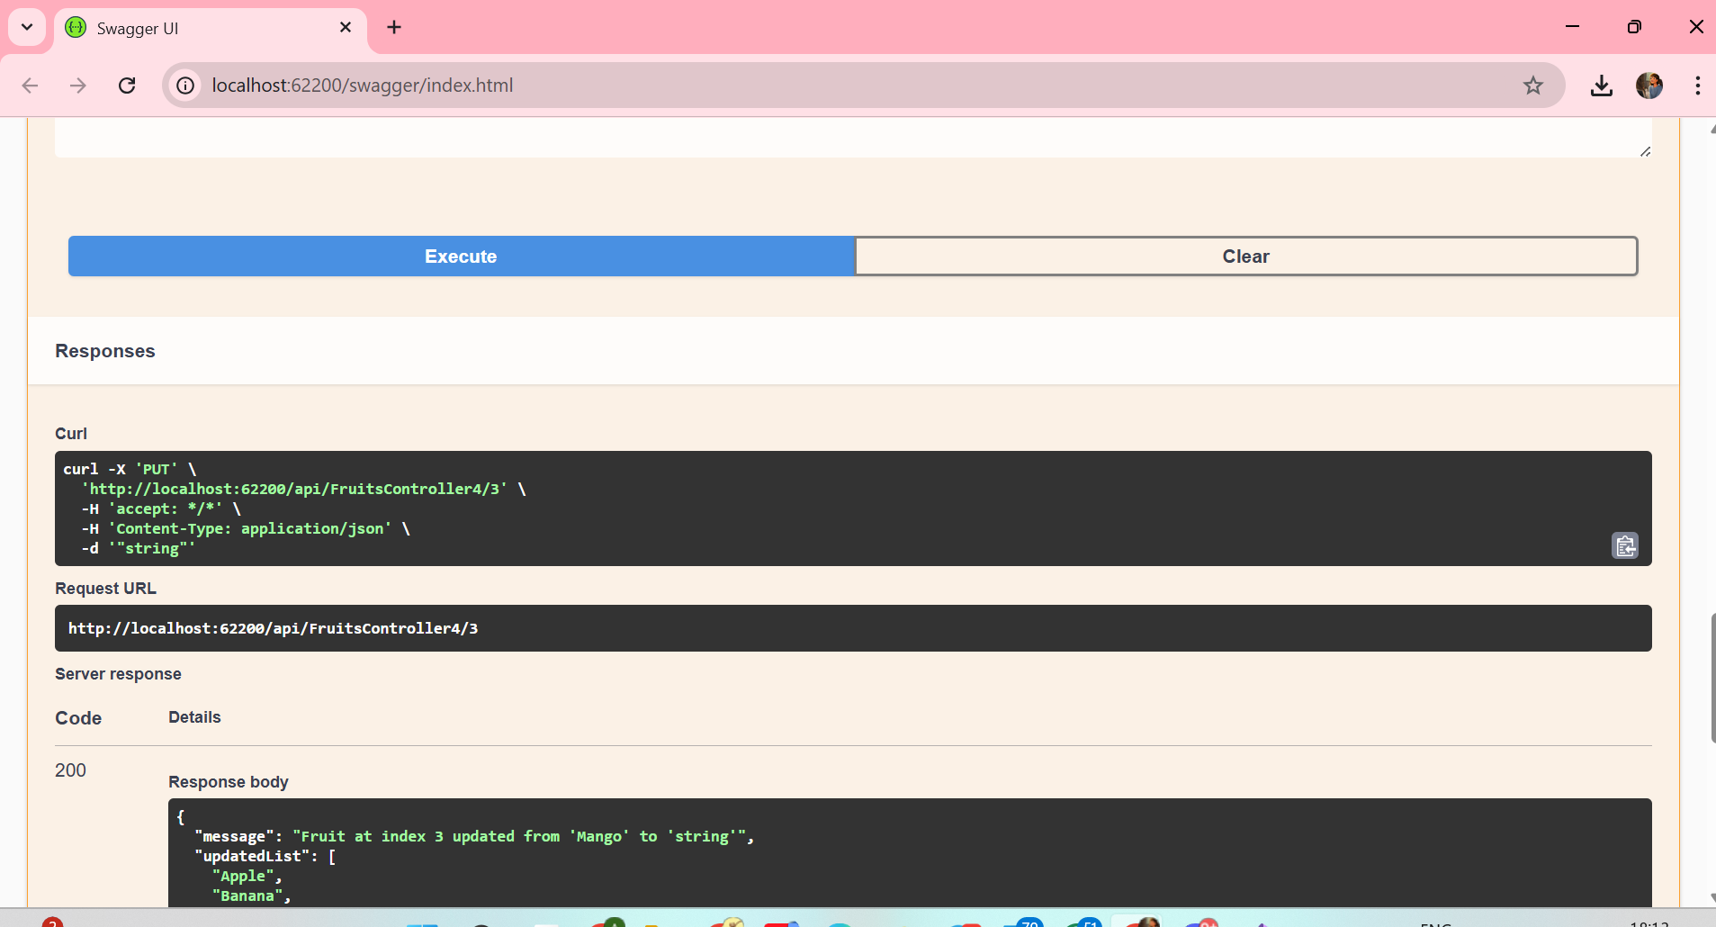
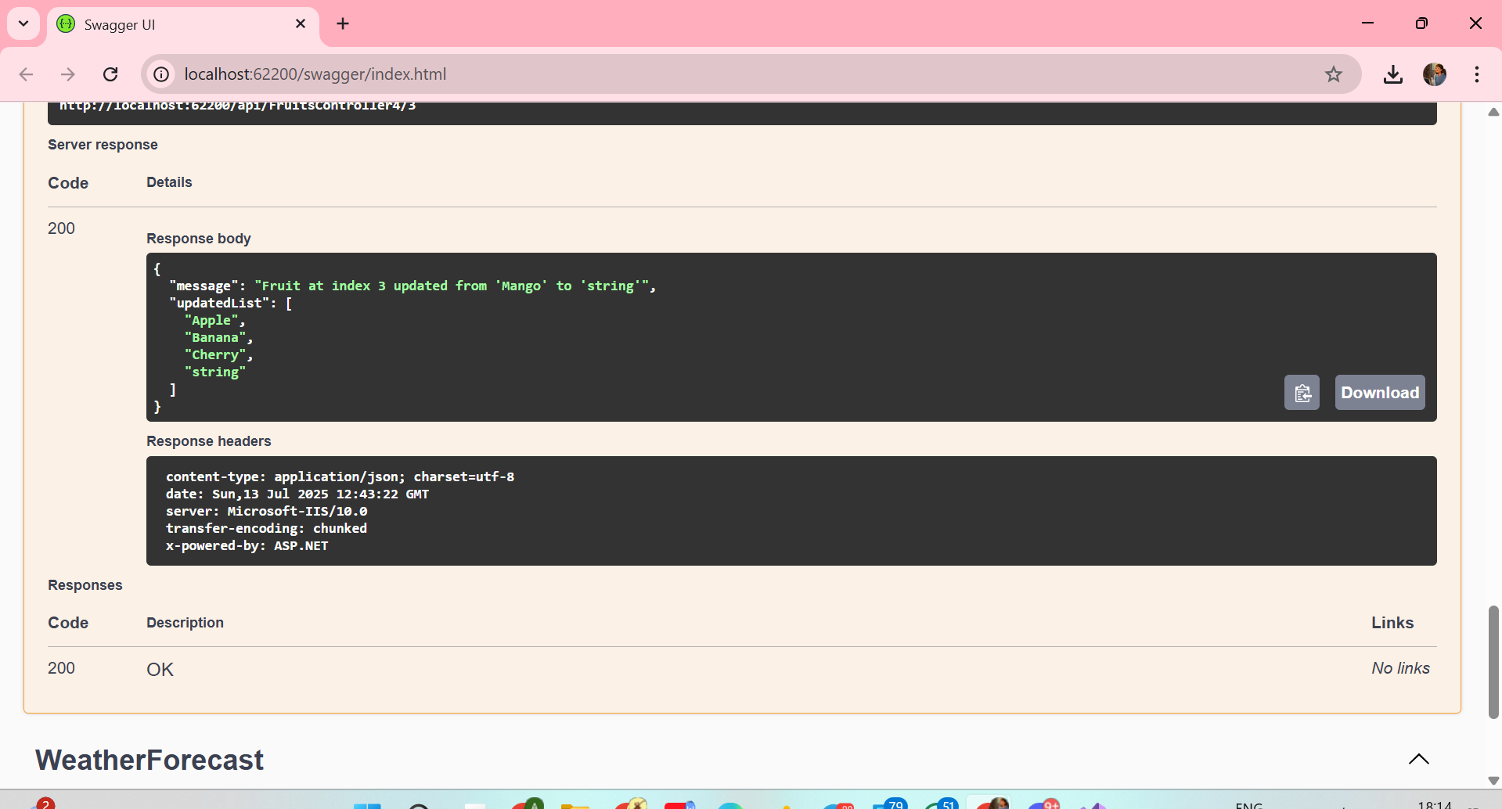

TASK 5 :-

FruitsController5.cs
using Microsoft.AspNetCore.Mvc;

namespace WebApi_Handson1.Controllers
{
[ApiController]
[Route("api/[controller]")]
public class FruitsController5 : ControllerBase
{
private static List<string> fruits = new List<string>
{
"Apple", "Banana", "Cherry", "Mango"
};

// GET: api/FruitsController5
[HttpGet]
public IActionResult GetAllFruits()
{
return Ok(fruits);
}

// DELETE: api/FruitsController5/2
[HttpDelete("{index}")]
public IActionResult DeleteFruit(int index)
{
if (index < 0 || index >= fruits.Count)
return NotFound("Fruit not found.");

string removedFruit = fruits[index];
fruits.RemoveAt(index);

return Ok(new
{
message = $"Deleted '{removedFruit}' from index {index}.",
updatedList = fruits
});
}
}
}

SCREENSHOTS(task 5):-

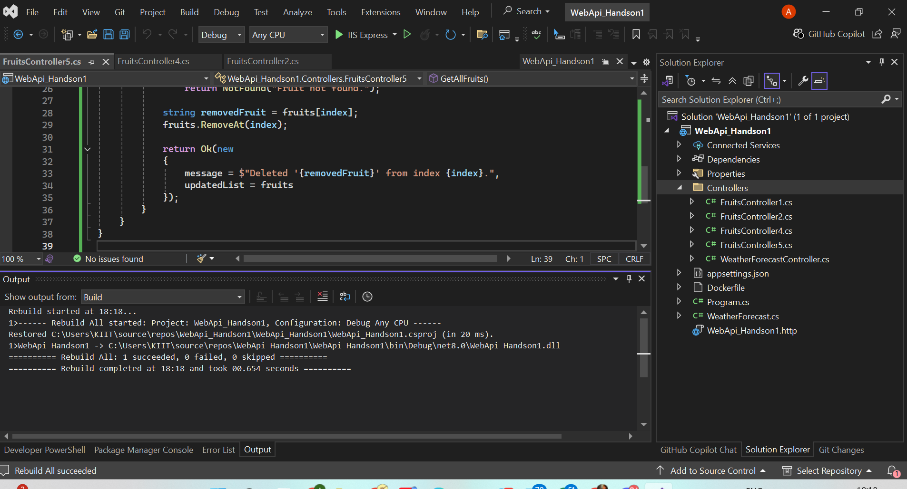
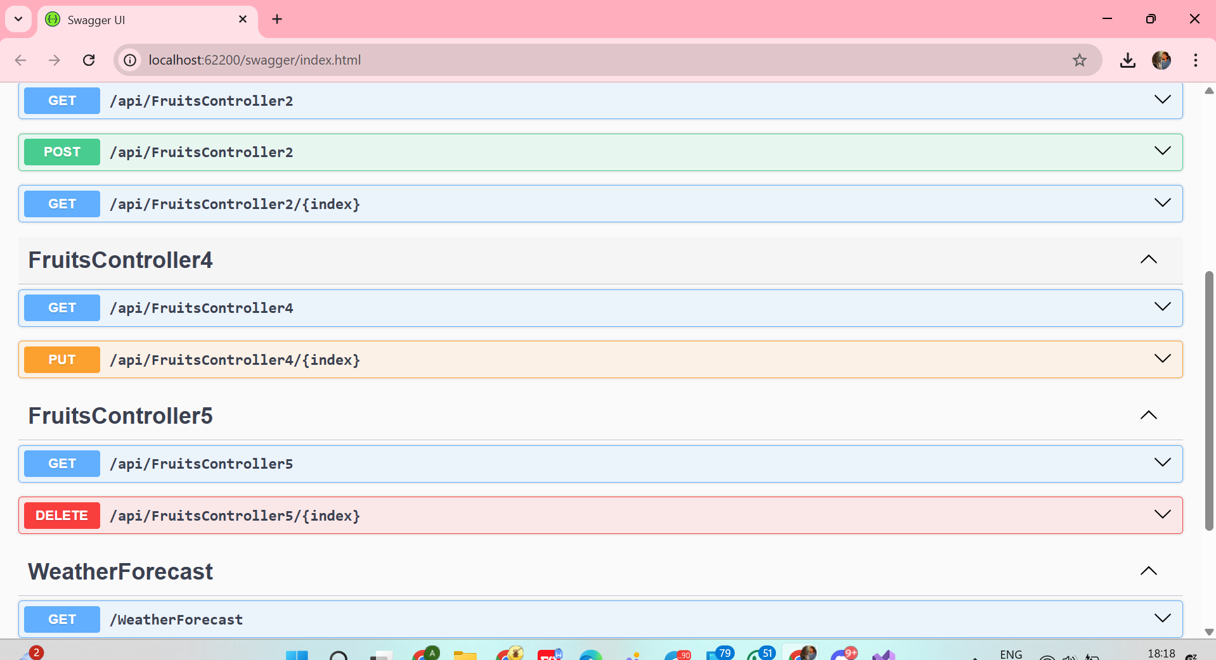
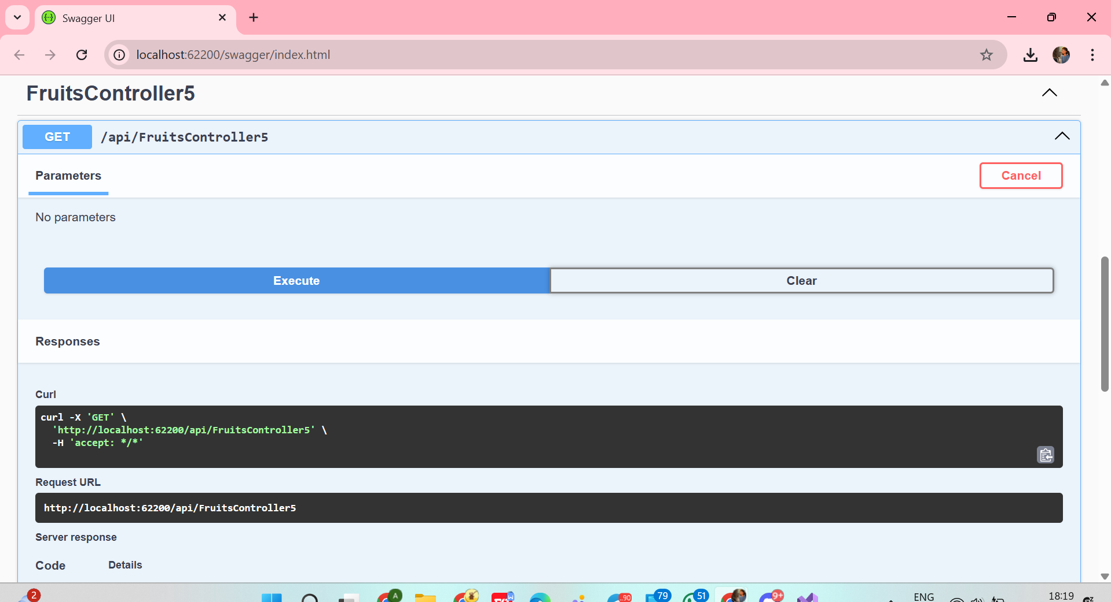
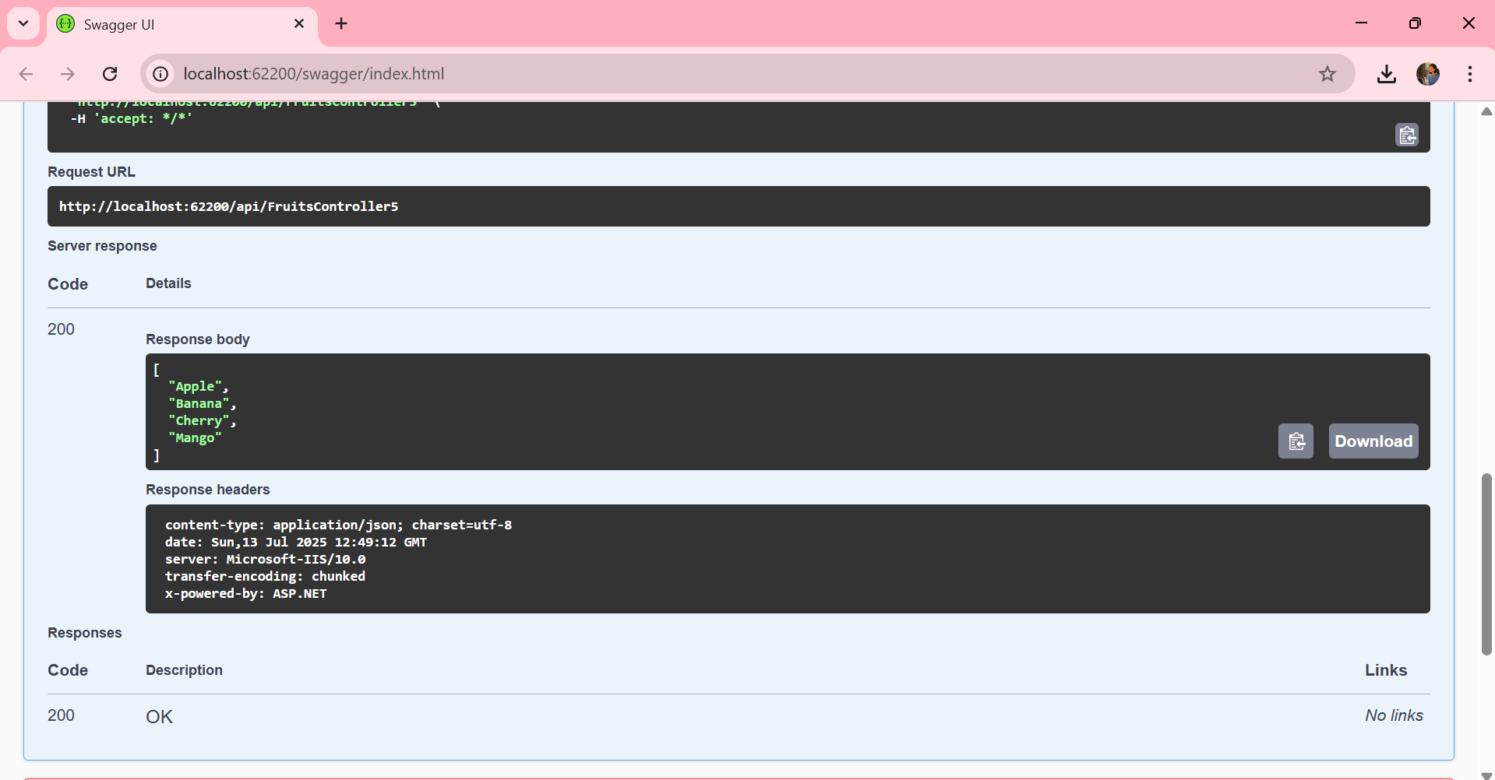
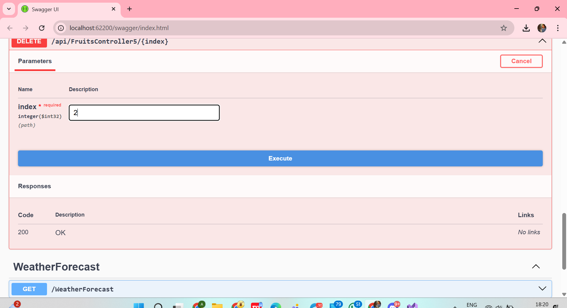
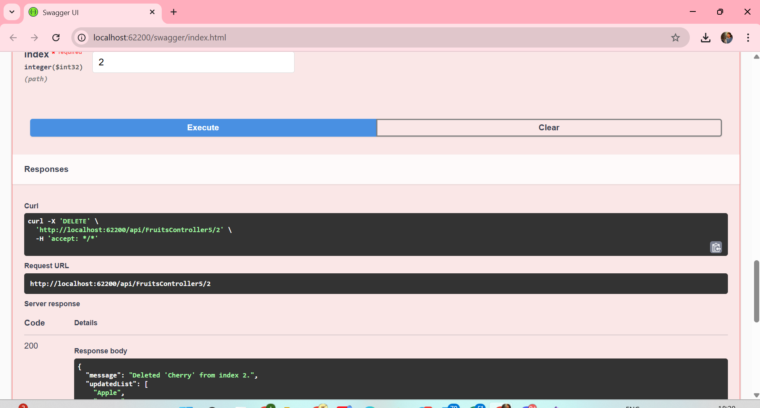
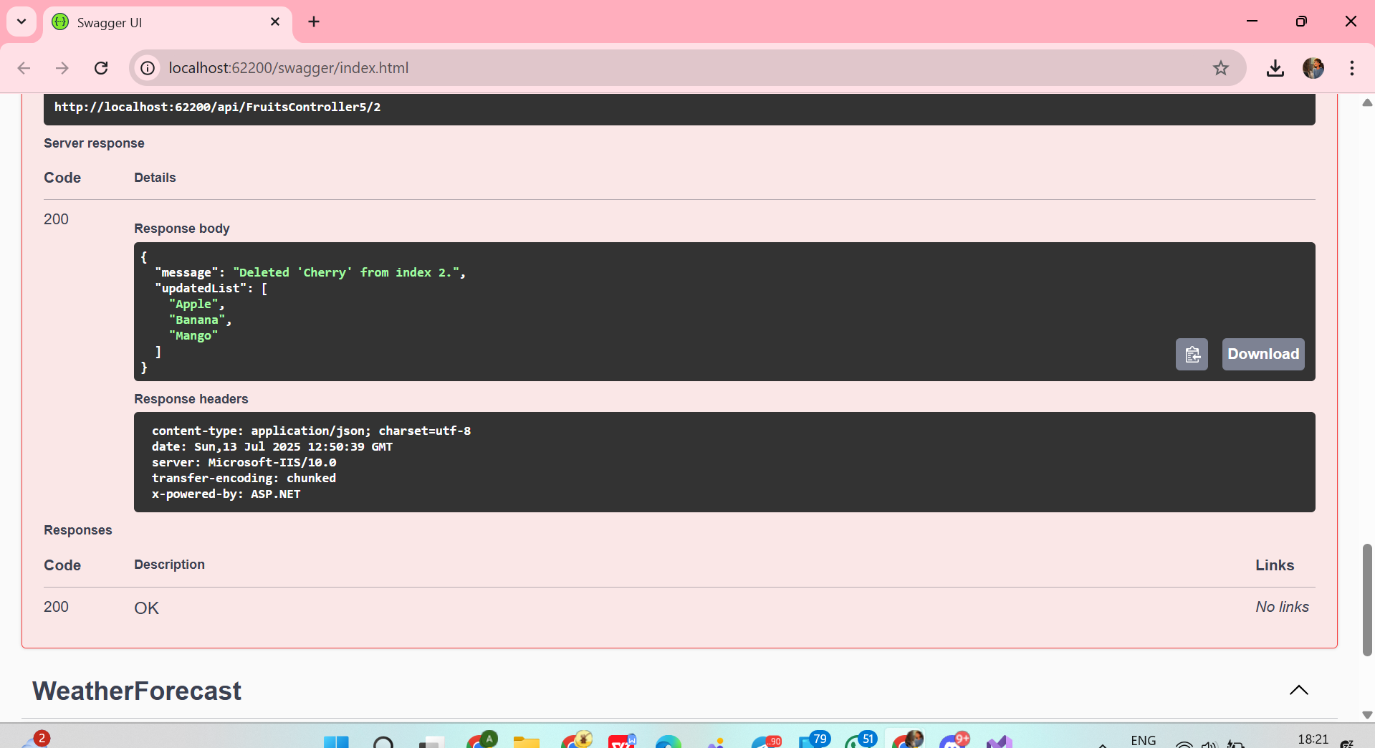

Completed Hands-On Summary
Exercise | Controller | Methods | Status
1 | FruitsController1 | GET | Done
2 & 3 | FruitsController2 | GET, POST | Done
4 | FruitsController4 | GET, PUT | Done
5 | FruitsController5 | GET, DELETE | Done

